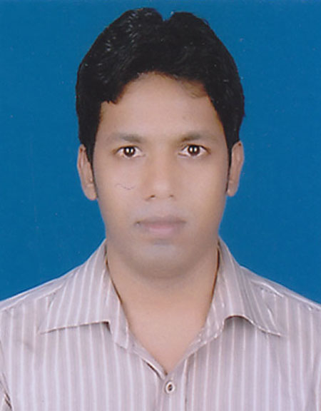

**CURRICULUM VITAE**

**OF**

**MD. OSMAN GANI SHAMIM**

***CAREER OBJECT:***

To be ***a member*** of your company so that I can share my acquired knowledge with You and contribute to the national & international development in the fields of sales, marketing, accounts and in many other fields where I get opportunity. I can assure you that I put my 100% effort to be an expert in very short period.

***PERSONAL INFORMATION:***

Name : Md. Osman Gani Shamim

Father’s Name : Mohammad Hossain

Mother’s Name : Saleha Begum

Permanent Address : C/O. Hossain Miar Bari

Vill: Jahajmara

Post: West Char Jabber

P.S: Char Jabber

Dist:Noakhali

Contact No. : 01725475199

Date of Birth : 01/01/1988

Marital Status : Single

Nationality : Bangladeshi

Religion : Islam (Sunny)

Blood Group : A (+ve)

Height : 5-6.5

Weight : 63 kg.

**M.Sc (Mathematics)**

***ACADEMIC QUALIFICATION:***

Institution : Noakhali Govt. College

Major : Mathematics

Year of Passing : 2010

Result : 1st Class

Board/ University : National University

**B.Sc Hons (Mathematics)**

Institution : Noakhali Govt. College

Passing Year : 2009

Major : Mathematics

Result : 1st Class

Board/ University : National University

**H.S.C (Higher Secondary Certificate)**

Institution : Noakhali Govt. College

Passing Year : 2005

Group : Science

GPA : 3.10

Board : Comilla

**S.S.C (Secondary School Certificate)**

Institution : Ramgoti B.B.K Pilot Model High School

Passing Year : 2003

Group : Science

GPA : 3.56

Board : Comilla

***LANGUAGE PROFICIENCY:***

* **English :**  Fluent in reading, writing and speaking.
* **Bengali :**  Mother tongue.

***COMPUTER PROFICIENCY:***

* MS Word, MS Excel, Power Point, Internet & E-mail.

**---------------------------**

**Osman Gani Shamim**

**Date:**